**Splunk Deployment Setup**

**Deployment client setup**

1. Go to $SPLUNK_HOME
2. Then go to $SPLUNK_HOME/etc/system/local/
3. Create a file called deploymentclient.conf

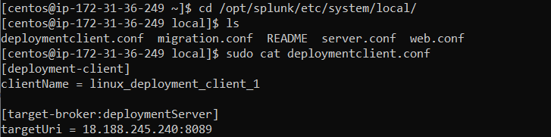

**to check the deployment client configured correctly**

1. Go to deployment server
2. Login splunk web of deployment server
3. Then go to settings -> Forward management (Distributed environment)

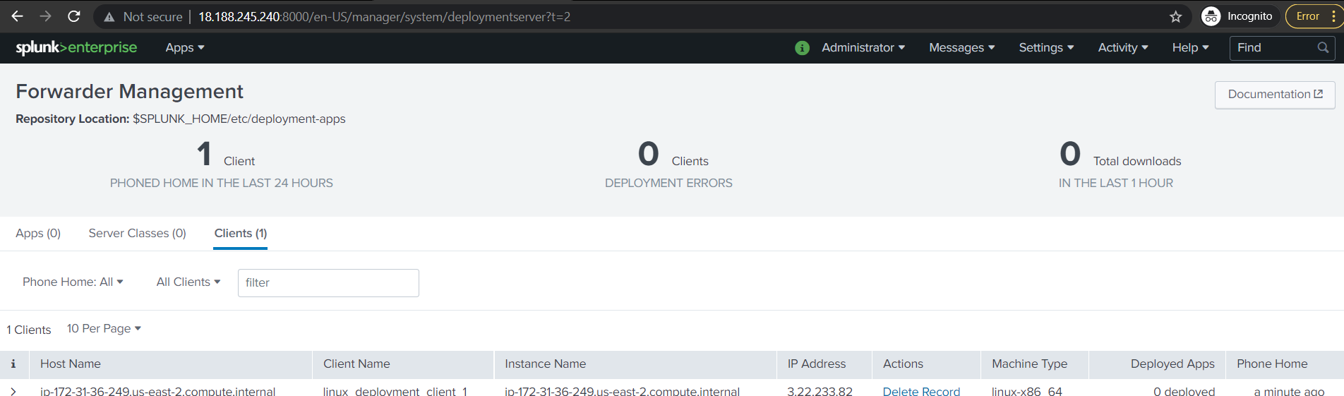

**Deployment server setup**

**To add apps to the deployment server**

1. Go to $SPLUNK_HOME
2. Then go to /$SPLUNK_HOME/et c/deployment-apps/
3. Make the directory for apps

$ mkdir linux_apps

**Serverclass setup**

**Method 1**

1. Login splunk web
2. Go to settings -> Forward management (Distributed Environment)
3. Then go to serverclass and click create one
4. Enter serverclass name and save

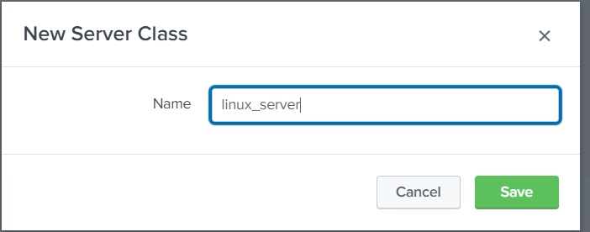

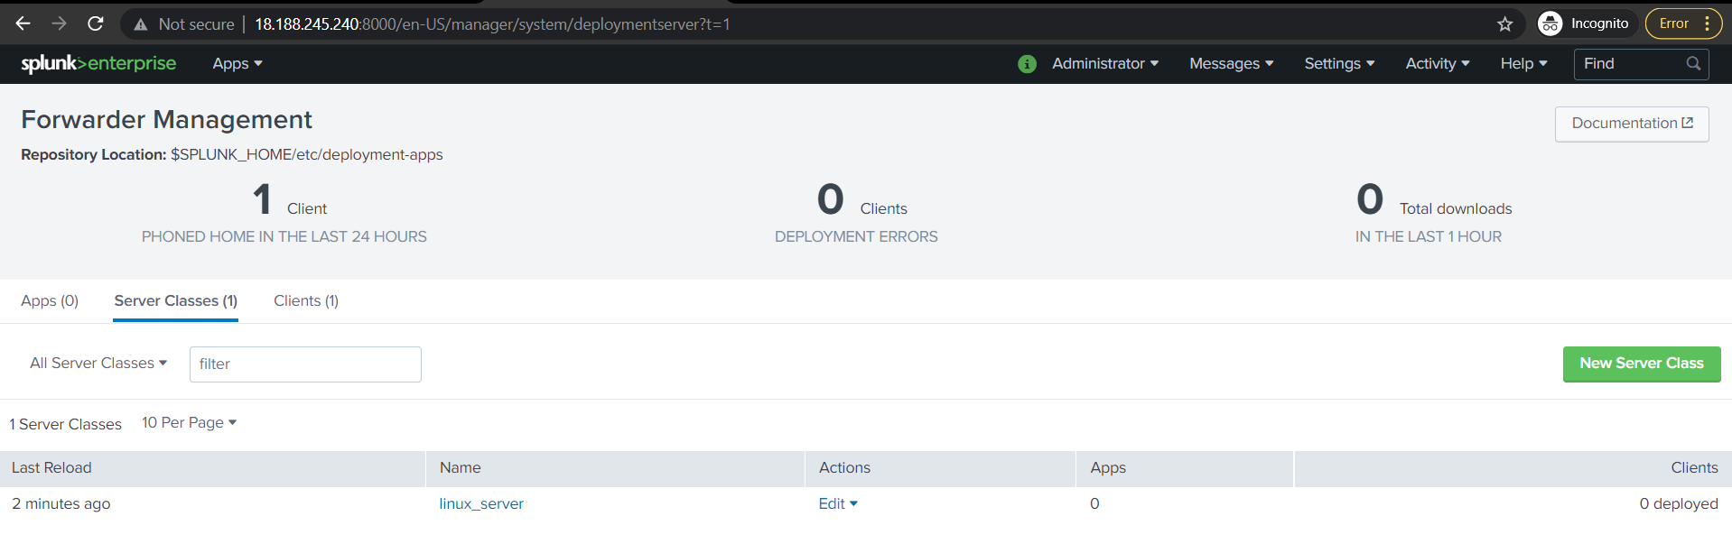

**Method 2**

1. Go to $SPLUNK_HOME/etc/system/local/
2. Create a new serverclass.conf file

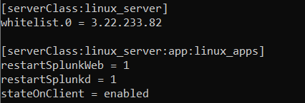

**To add clients to the serverclass**

1. Click on server class to add clients
2. Then click add clients

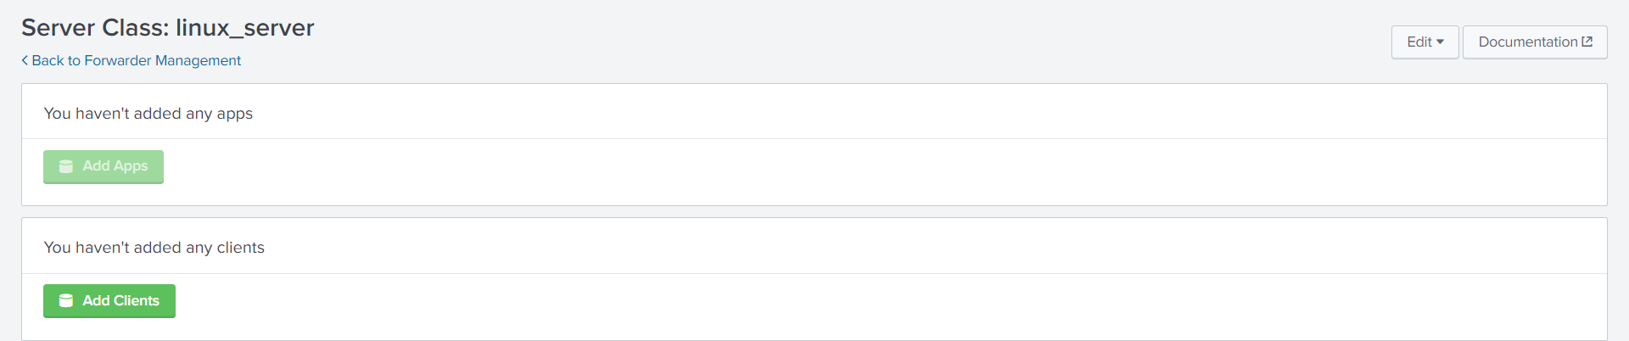

1. Then enter the client ip address or name in the whitelist

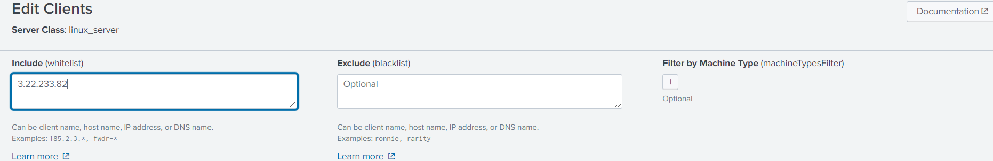

1. Then click save

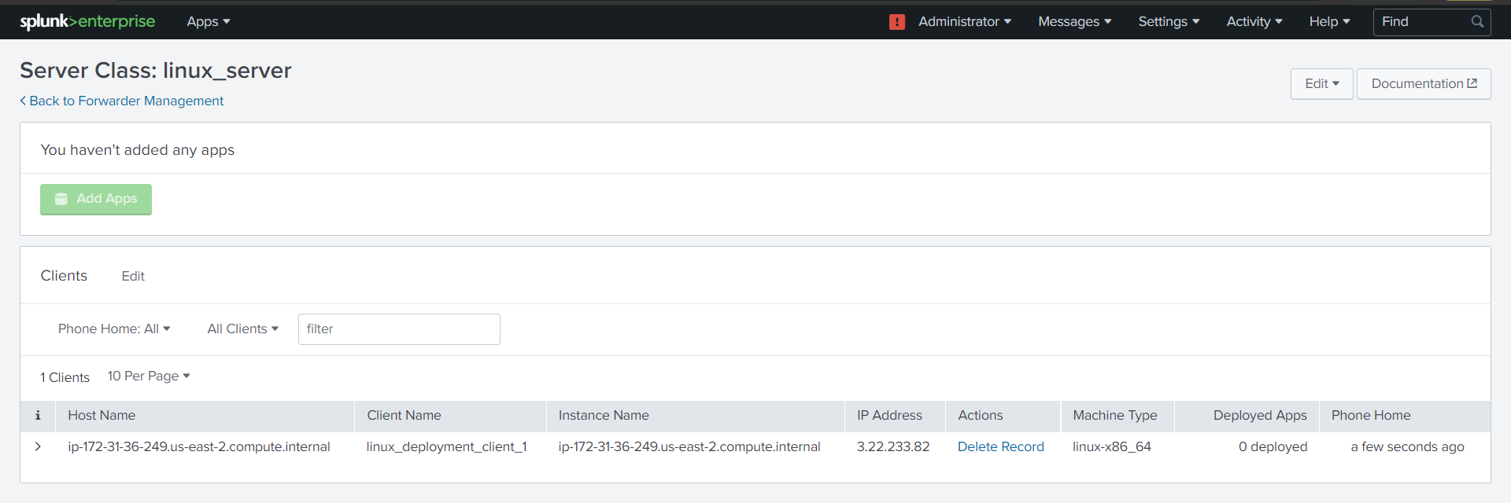

**To add apps to server class**

1. Go to settings -> Forward management (Distributed environment)
2. Then go to server class and select server class to add apps
3. Then click on add apps

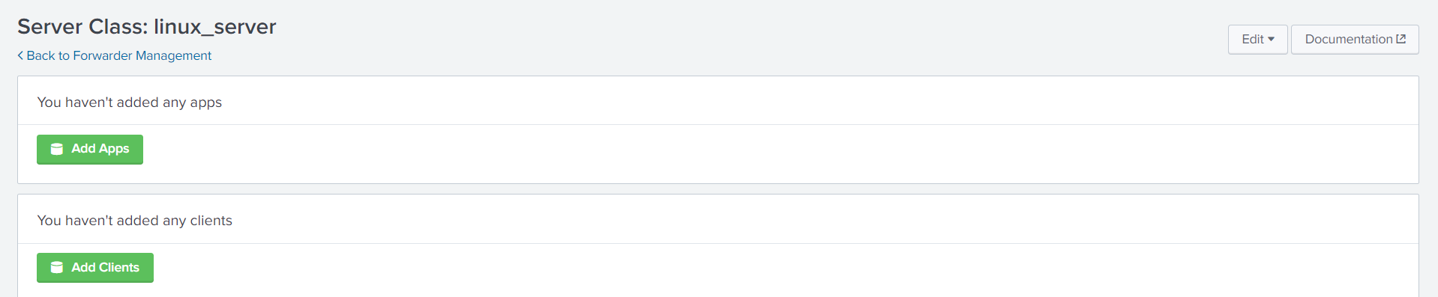

1. Select the app you want to add to that serverclass

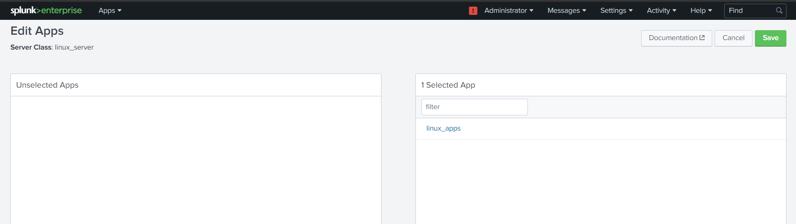

1. Click save

